
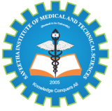
SIMATSENGINEERING

Saveetha Institute of Medical and Technical Sciences
Chennai- 602105

Student Name: V.Dharanireddy Reg. No.: 192311219
Course Code: CSA1305 Slot: D
Course Name: INTERNET PROGRAMMING
Course Faculty: Dr. D.Sudhagaran
Project Title: Nutri smart AI personalized nutrition , reciepe recommendation and budget meal planning
Module Photographs: (2 photographs –Module photo contribution module work in the project and presentation image)
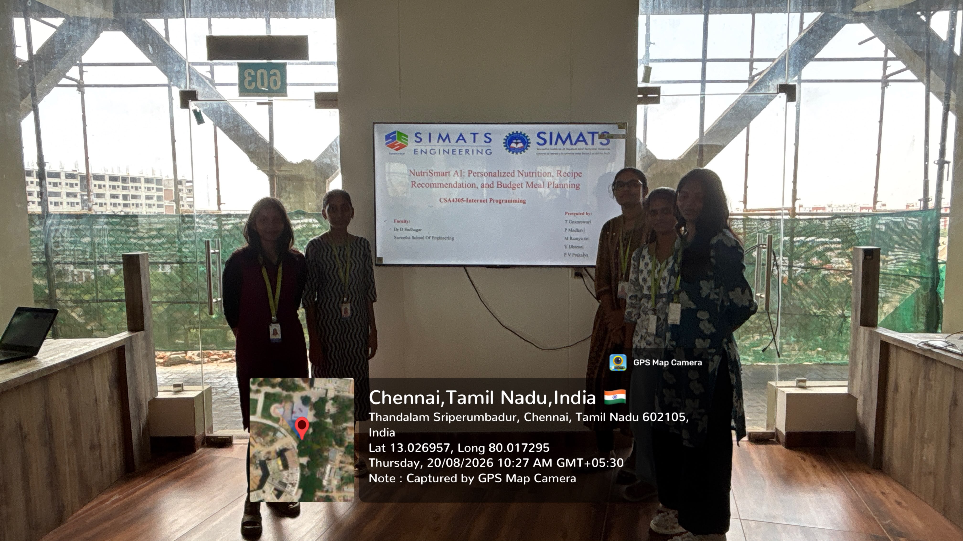 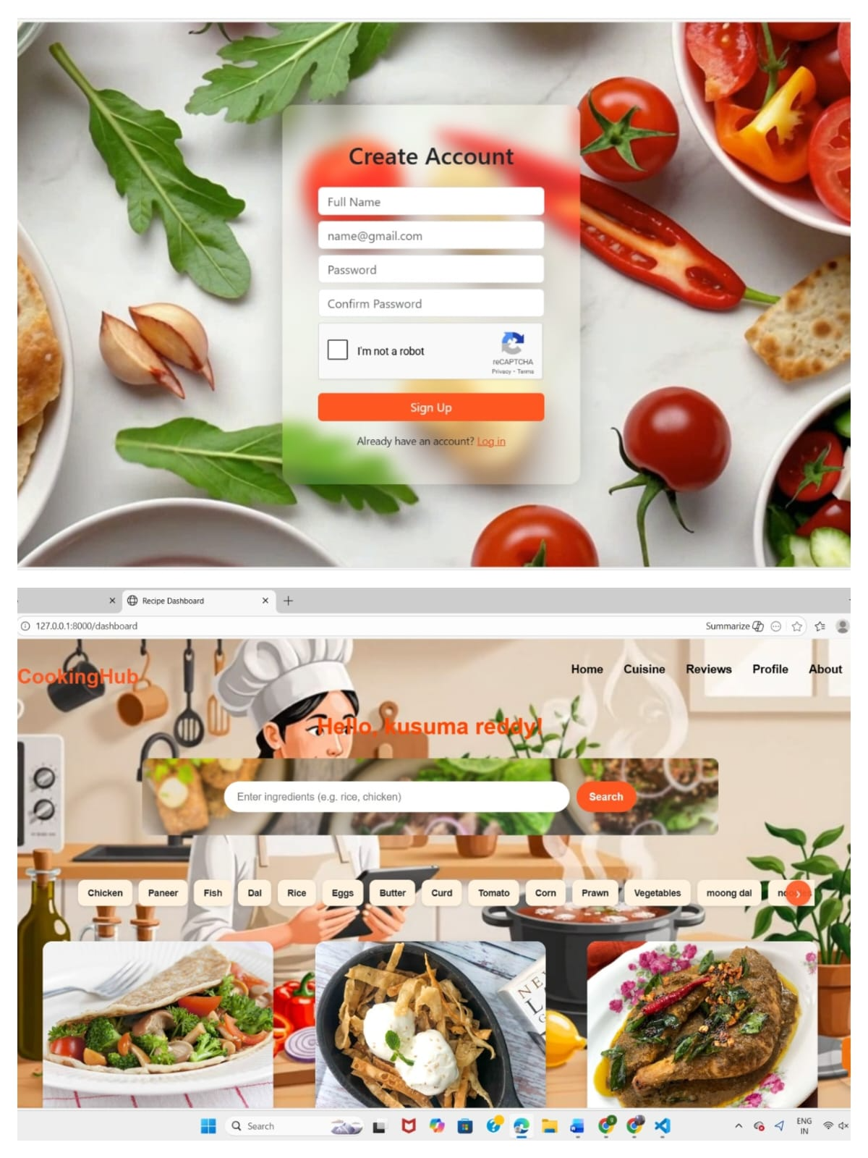 Output
Project Description: (here you write what you did in this project (contribution) including Model Description
NutriSmart AI is an intelligent and personalized nutrition platform designed to help individuals maintain a healthy lifestyle while managing their food expenses effectively. The system uses Artificial Intelligence to understand each user’s nutritional requirements, health goals, dietary preferences, allergies, food habits, and budget. Based on this information, NutriSmart AI generates personalized meal plans and recommends healthy recipes that match the user’s needs. It also provides important nutritional information such as calories, protein, carbohydrates, fats, fiber, and other essential nutrients, helping users make informed decisions about their food.
One of the key features of NutriSmart AI is its budget-friendly meal planning capability. Users can specify their daily or weekly food budget, and the system recommends nutritious meals that fit within the available budget. It can generate smart grocery lists, suggest affordable ingredient alternatives, and make use of ingredients that are already available at home. The recipe recommendation system can also consider cooking time, meal preferences, cuisine choices, and available ingredients to provide practical and personalized suggestions

V.Dharani DR.D.Sudhagaran Student Signature Guide Signature

